Overview of Narrative GPR Index Coding Guidelines

Dario Caldara, Matteo Iacoviello, Patrick Molligo and Charlotte Singer

Contents

Overview 2

Initial Guidelines 3

Notes 3

Examples 4

Example 1: Photo as a lead article 4

Example 2: Photo associated with article 5

Example 3: Photo as tie breaker 6

Example 4: Article under photo 7

Example 5: Article to be coded as 1. 8

Example 6: Article to be coded as 2. 9

Example 7: Article to be coded as 5 10

# Overview

* This note provides an overview of the guidelines used to code the front pages of the New York Times from 1900 through 2019.
* Each coder is required to open the file containing the relevant front page and code is as 0, 1, 2, or 5 depending on how geopolitical tensions are featured in that page.
* The basic guidelines are:
* no headline discusses rising or existing geopolitical tensions 🡪 score: 0;
* one headline---but not the lead headline---discusses geopolitical tensions 🡪 score: 1;
* the lead headline---but not a banner headline---discusses geopolitical tensions 🡪 score: 2;
* the banner headline discusses geopolitical tensions 🡪 score: 5.

# Initial Guidelines

* **Is the article missing?**
  + **Yes: Code an m**
  + **No: Is there a GPR banner articles mentioning GPR across the entire page?**
    - **Yes:** **Code a 5**
    - **No:** **Is there a GPR main/lead article**?
      * 1. Width/number of columns is most important
      * 2. Check largest font size to break ties
      * 3. Check associated picture to break ties
      * 4. Check centrality of article to break ties
      * **Yes: Code a 2**
      * **No: Is there a GPR front page article?**
        + **Yes: Code a 1**
        + **No: Code a 0**

# Notes

* If in doubt, assume article talks about geopolitical risks, unless the article is convincingly rejecting that. Easing tensions, however, imply no geopolitical risks
  + E.g., “peace talks resume, but road ahead is complicated” means GPR = YES
  + “peace signed, big party” means GPR = NO
* Article Banner, main, and front articles are distinct, not subsets/supersets of each other
* All hits are indicators, not counts
  + Banner = 5; and include keyword or event
  + Lead = 2
  + Front = 1
  + Missing article = “m”
* A Non-GPR article should be coded as a GPR article if context tells us it is directly caused by GPR
  + For example, see Sep 18th, 2001
* If number of columns, font, and centrality are identical, we consider there to be multiple lead articles
* A feature picture with clear title either above or directly below can count as a lead article
  + A picture without a title doesn’t count
* Adjacent pictures do not count towards column width
* An article is only considered a front page article if it is at the top of the page
* One column articles can be lead articles (very common

# Examples

### Example 1: Photo as a lead article

In this example, because we can read the title associated with the photograph and the photograph takes up the greatest number of columns, it becomes the main article. The other two articles on the top row are front page articles, and any articles below the top row are disregarded.

This page is coded as 1

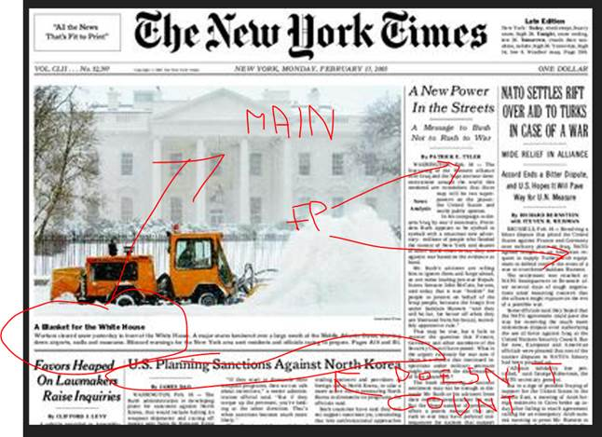

### Example 2: Photo associated with article

In this example, the photograph is associated with the article to the right. While together they take up the greatest number of columns, in determining the main article we only take into account the number of columns the title spans. In this case, the main article becomes the one on the left, and the other two articles on the top row become front page articles.

This page is coded as 1.

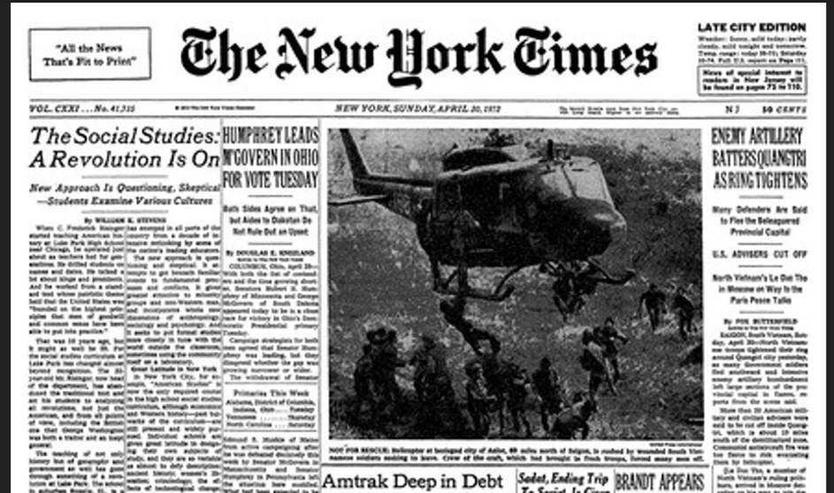

### Example 3: Photo as tie breaker

In this example, the photo in the center seems to be associated with the article “Cahill’s Top Aide Indicted in Alleged Kickback Plot”. That article and the article “South Vietnamese Launch Push to Retake Quangtri” both span the most columns and both have equal font size. Without the photo there, they would have both been coded as main articles, but with the photo there, it acts as a tie breaker, making “Cahill’s Top Aide Indicted in Alleged Kickback Plot” the main article. The other articles on the top row become front page articles.

This page is coded as 1.

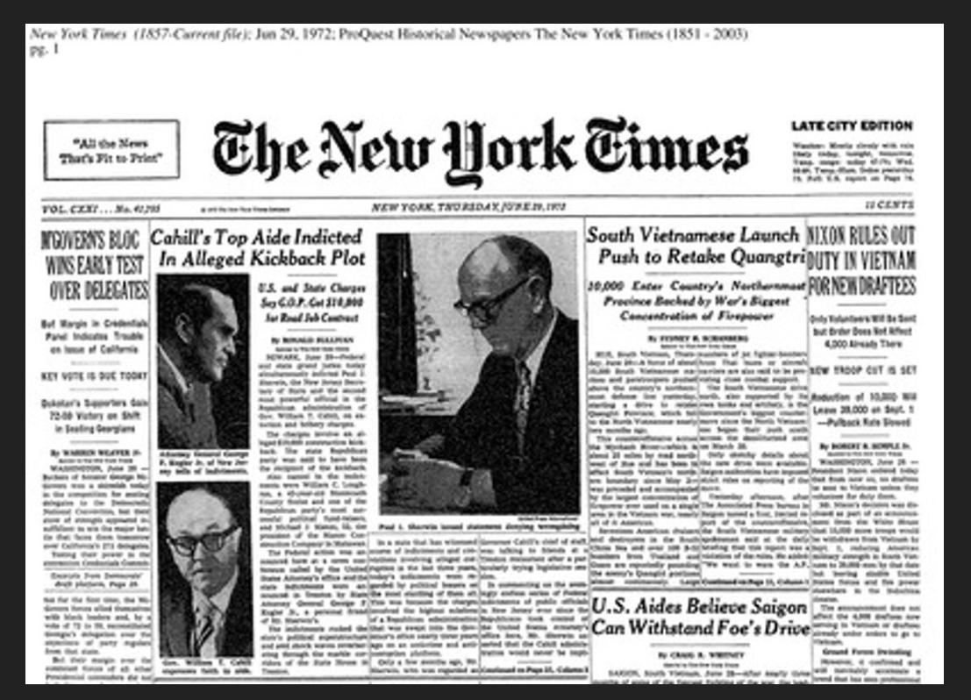

### Example 4: Article under photo

In this example, the article “Frontier Insurgency Spills Into a Pakistani City” is associated with the large photo, making it at least a front page article, potentially a main article, despite not being in the top row. Since its title takes up more columns than the that of the article “Fed Chief’s Reassurance Fails to Halt Stock Plunge”, it is the main article.

This page is coded as 2.

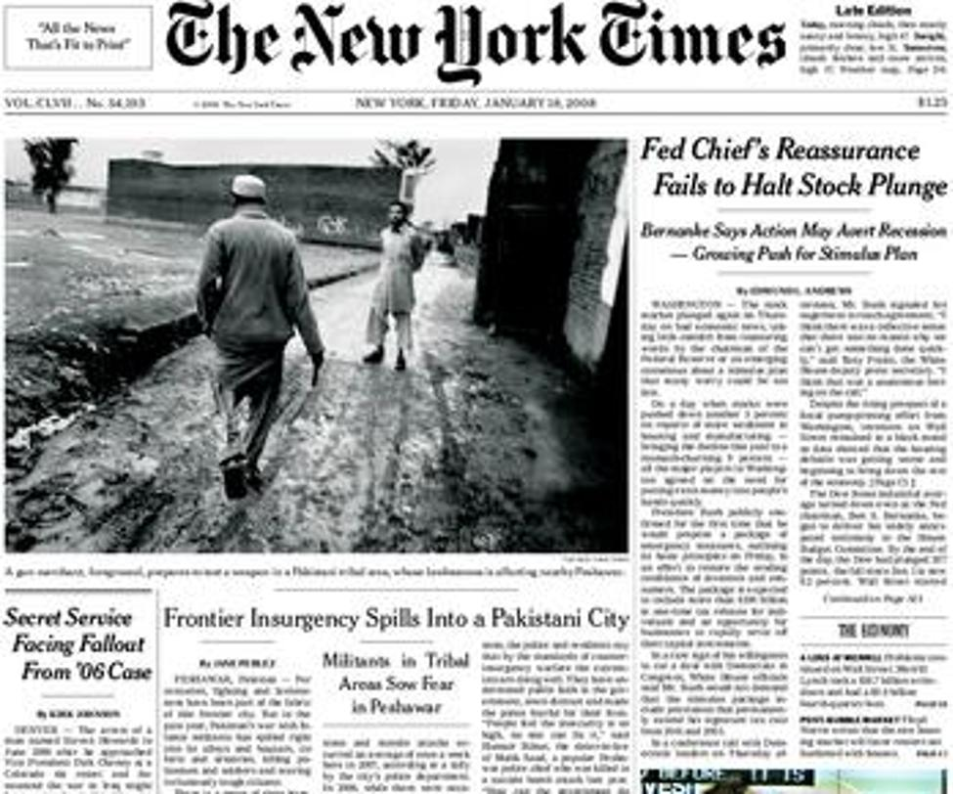

### Example 5: Article to be coded as 1.

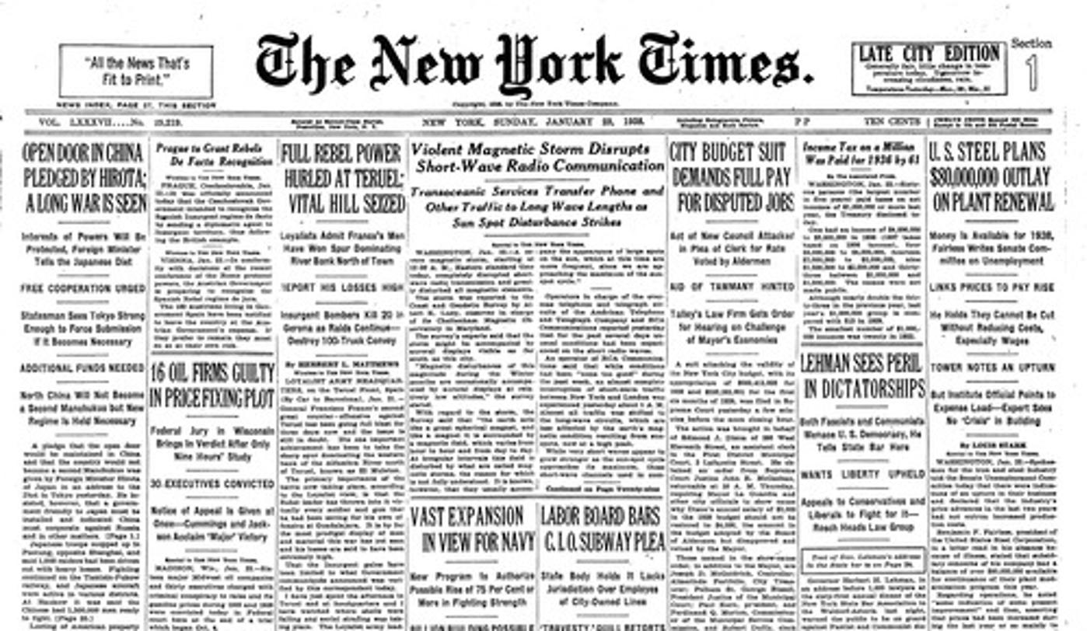

### Example 6: Article to be coded as 2.

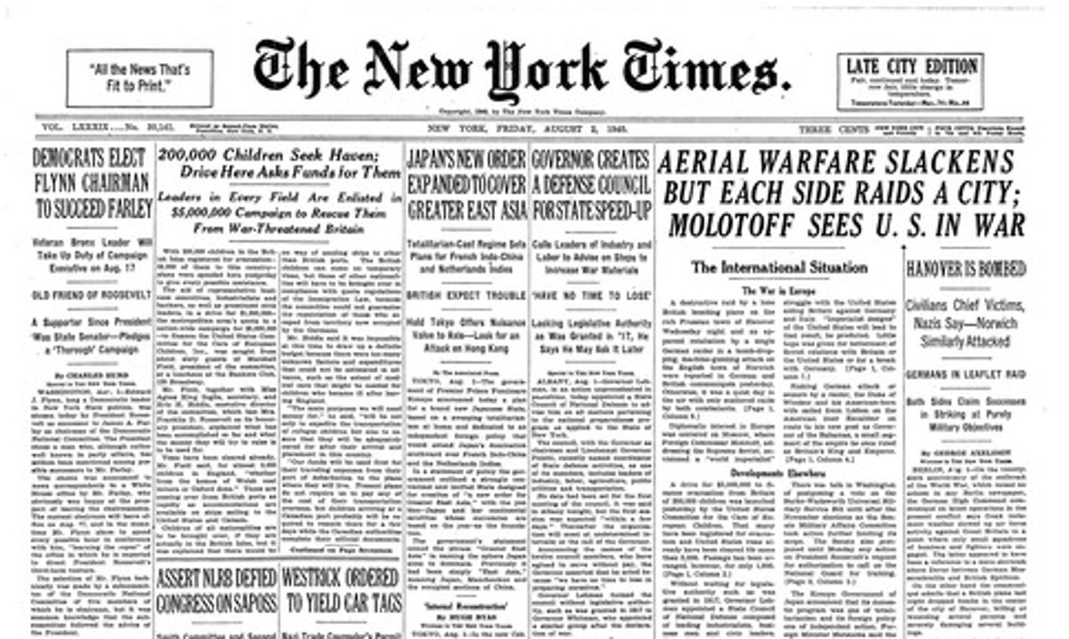

### Example 7: Article to be coded as 5

